If Statement (Conditional Statement)

The [if()](https://www.arduino.cc/en/Reference/If) statement is the most basic of all programming control structures. It allows you to make something happen or not, depending on whether a given condition is true or not. It looks like this:

if (someCondition) {

// do stuff if the condition is true

}

There is a common variation called if-else that looks like this:

if (someCondition) {

// do stuff if the condition is true

} else {

// do stuff if the condition is false

}

There's also the else-if, where you can check a second condition if the first is false:

if (someCondition) {

// do stuff if the condition is true

} else if (anotherCondition) {

// do stuff only if the first condition is false

// and the second condition is true

}

You'll use if statements all the time. The example below turns on an LED on pin 13 (the built-in LED on many Arduino boards) if the value read on an analog input goes above a certain threshold.

Hardware Required

* Arduino or Genuino Board
* Potentiometer or variable resistor

Circuit

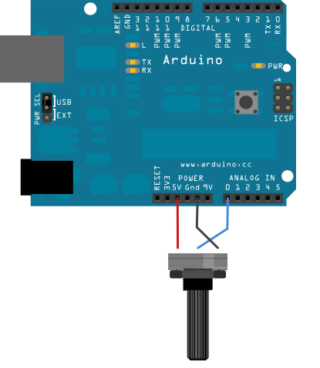

Schematic

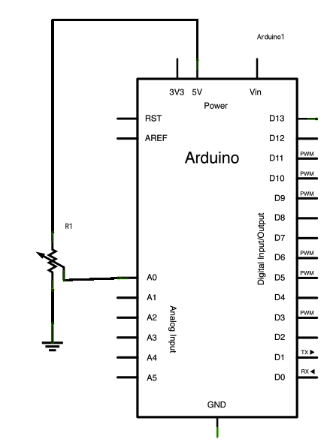

Code

In the code below, a variable called analogValue is used to store the data collected from a potentiometer connected to the board on analogPin 0. This data is then compared to a threshold value. If the analog value is found to be above the set threshold the built-in LED connected to digital pin 13 is turned on. If analogValue is found to be < (less than) threshold, the LED remains off.

*// These constants won't change:*  
const int analogPin = A0;    *// pin that the sensor is attached to*  
const int ledPin = 13;       *// pin that the LED is attached to*  
const int threshold = 400;   *// an arbitrary threshold level that's in the range of the analog input*  
  
void **setup**() {  
  *// initialize the LED pin as an output:*  
  pinMode(ledPin, OUTPUT);  
  *// initialize serial communications:*  
  // Serial.begin(9600);  
}  
  
void **loop**() {  
  *// read the value of the potentiometer:*  
  int analogValue = analogRead(analogPin);  
  
  *// if the analog value is high enough, turn on the LED:*  
  if (analogValue > threshold) {  
    digitalWrite(ledPin, HIGH);  
  } else {  
    digitalWrite(ledPin, LOW);  
  }  
  
  *// print the analog value:*  
  // Serial.println(analogValue);  
  delay(1);        *// delay in between reads for stability*  
}